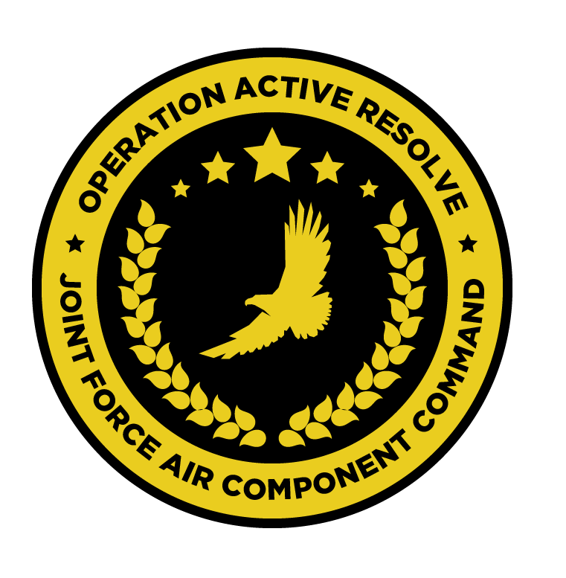

JFACC JOINT AIR OPERATIONS PLAN

OPERATION ACTIVE RESOLVE

# Situation.

Briefly describe the situation that the plan addresses (see JFC's estimate). The related CONPLAN or OPLAN should be identified as appropriate.

Guidance. Provide a summary of directives, letters of instructions, memorandums, treaties, and strategic plans, including any campaign/operation plans received from higher authority, that apply to the plan.

(1) Relate the strategic direction to the JFC's requirements.

(2) List the strategic objectives and tasks assigned to the command.

(3) Constraints--list actions that are prohibited or required by higher authority (ROE, and others as appropriate).

## Adversary Forces.

Provide a summary of pertinent intelligence data including information on the following:

(1) Composition, location, disposition, movements, and strengths of major adversary forces that can influence action in the AOR/JOA.

(2) Strategic concept (if known), should include adversary's perception of friendly vulnerabilities and adversary's intentions regarding those vulnerabilities.

(3) Major objectives (strategic and operational).

(4) Adversary commander's idiosyncrasies and doctrinal patterns.

(5) Operational and sustainment capabilities.

(6) Vulnerabilities.

(7) Centers of gravity and decisive points.

NOTE: Assumed information should be identified as such. Reference may be made to the intelligence annex for more detailed information.

## Friendly Forces.

State here information on friendly forces not assigned that may directly affect the command.

(1) Intent of higher, adjacent, and supporting US commands (e.g., USTRANSCOM, USSTRATCOM, USSOCOM, USSPACECOM).

(2) Intent of higher, adjacent, and supporting allied or other coalition forces (e.g., NATO, Spain, Italy, Egypt).

Assumptions. State here assumptions applicable to the plan as a whole. Include both specified and implied assumptions.

# Mission.

State the joint air task(s) and the purpose(s) and relationship(s) to achieving the JFC's objective(s).

# Air Operations

Strategic or Operational Concept. (Based on the relevant major elements of JFC strategy.) State the broad concept for the deployment, employment, and sustainment of major air capable joint forces including the concepts of deception and psychological operations during the operation or campaign as a whole. (This section is a summary of details found in annexes.)

## Joint force air organization.

* 132nd Virtual Wing
  + 617th Squadron
  + 696th Squadron
  + 259th Squadron
  + 494th Squadron
  + 108th Squadron
  + 388th Squadron
  + 23rd JTAC Squadron
  + 176th AWACS Squadron
* KC-135 MPRS Squadron
* KC-135 Squadron
* 2x Patriot Battalions

## Joint force air objectives.

TBD

## Beddown overview.

* 132nd Virtual Wing: Split between Incirlick and Ramat David Airbase
  + 617th: 1 detachement Incirlik and one detachment at Ramat David Airbase
  + 696th: 1 detachement Incirlik and one detachment at Ramat David Airbase
  + 259th: 1 detachement Incirlik and one detachment at Ramat David Airbase
  + 388th: 1 detachement Incirlik and one detachment at Ramat David Airbase
  + 494th Squadron: Carrier
  + 108th Squadron: Carrier
* KC-135 MPRS Squadron: Incirlick
* KC-135 Squadron: Incirlick
* Patriot BN 1: Incirlick
* Patriot BN 2: Ramat David Airbase

## Operational missions.

## Phases of joint air operations in relation to JFC operation or campaign plan.

## Timing and duration of phases.

### Phase I. Provide a phase directive for each phase.

#### (1) Operational Concept.

Include operational objectives, plan of attack, and timing.

#### (2) General missions and guidance to subordinates and components' supporting and supported requirements.

Ensure that missions are complementary.

#### (3) Capabilities/forces required by role or capability.

Should consider land, sea, air, space, special operations, and multinational.

#### (4) Tasks of subordinate commands and components.

#### (5) Reserve Forces.

Location and composition. State "be prepared" missions. Include guidance on surge sorties if used as reserve capability.

#### (6) Mobility.

Consider transportation, ports, lines of communication, transit and overflight rights, reinforcement, reception and onward movement, and host-nation support arrangements.

#### (7) Deception.

#### (8) Psychological Operations.

Ensure joint air operations support established psychological operations.

Phases II-XX (last). Cite information as stated in subparagraph 3b above for each subsequent phase. Provide a separate phase for each step in the operation at the end of which a major reorganization of forces may be required and another significant action initiated.

Coordinating Instructions. If desired, instructions applicable to two or more phases or multiple elements of the command may be placed here.

# Logistics.

Brief, broad statement of the sustainment concept for the joint air operations with information and instructions applicable to the joint air operations by phase. Logistic phases must be consistent with operational phases. This information may be listed separately and referenced here. This paragraph should address:

Assumptions (including coalition requirements).

Supply aspects.

Maintenance and modifications.

Medical service.

Transportation.

Base development.

Personnel.

Foreign military assistance

Administrative management.

Line(s) of communication.

Reconstitution of forces.

Joint and multinational responsibilities.

Sustainment priorities and resources.

Inter-Service responsibilities.

Host-nation considerations.

# Command. Control. and Communications

## Command

(1) Command Relationships. State generally the command relationships for the entire joint air operations or portions thereof. Indicate any transfer of forces contemplated during the joint air operations, indicating the time of the expected transfer. These changes should be consistent with the operational phasing in paragraph 3. Give location of commander, JAOC, and command posts.

(2) Delegation of Authority.

## Communications

(1) Communications. Plans of communications. (May refer to a standard plan or be contained in an annex.) Include time zone to be used; rendezvous, recognition, and identification instructions; code; liaison instructions; and axis of signal communications as appropriate.

(2) Electronics. Plans of electronic systems. (May refer to standard plan or may be contained in an annex.) Include electronic policy and such other information as may be appropriate.

(3) Combat Camera Plans for combat camera. (May refer to a standard plan or may be contained in a combat camera annex.) Include digital still photo and motion video imagery transmission to the Pentagon's Joint Combat Camera Center

(4) Armament Delivery Recording (ADR) (bomb and gun camera imagery). Plan for ADR. (May refer to a standard plan or may be contained in a combat camera annex.) Include imagery transmission to the Pentagon's Combat Camera Center.

(Signed) (Commander)

MASTER ATTACK PLAN:

Destroy/ neutralise air defence command and control.

•Destroy nuclear, biological and chemical storage and production capability.

•Make ineffective the national and military command, control and communicationsinfrastructure.

•Destroy key electrical grids and oil storage facilities.

•Deny military resupply capability.

•Eliminate the long-term offensive capability.

•Make the Syrian ground forces ineffective.